WEB ENGINEERING (Spring Boot + Spring Data JPA + REST)

Course Learning Outcomes (CLOs)
CLO-1: Apply object-oriented programming and ORM concepts to design and implement domain models using Spring Boot & JPA. (Entities, relationships, repositories, services)
CLO-2: Develop REST APIs using Spring Boot including routing, controllers, data binding, and JSON responses. (REST endpoints, controllers, payloads)
CLO-3: Test, validate, and analyze RESTful web services using Postman, including CRUD requests and JSON payloads. (Postman calls, testing outputs)

Expense Management System

SECTION A — Case Study
You are required to develop a RESTful Expense Management System for a small team.
The database contains:
- Members who will submit expenses
- Categories of expenses
- Expenses recorded against members and categories
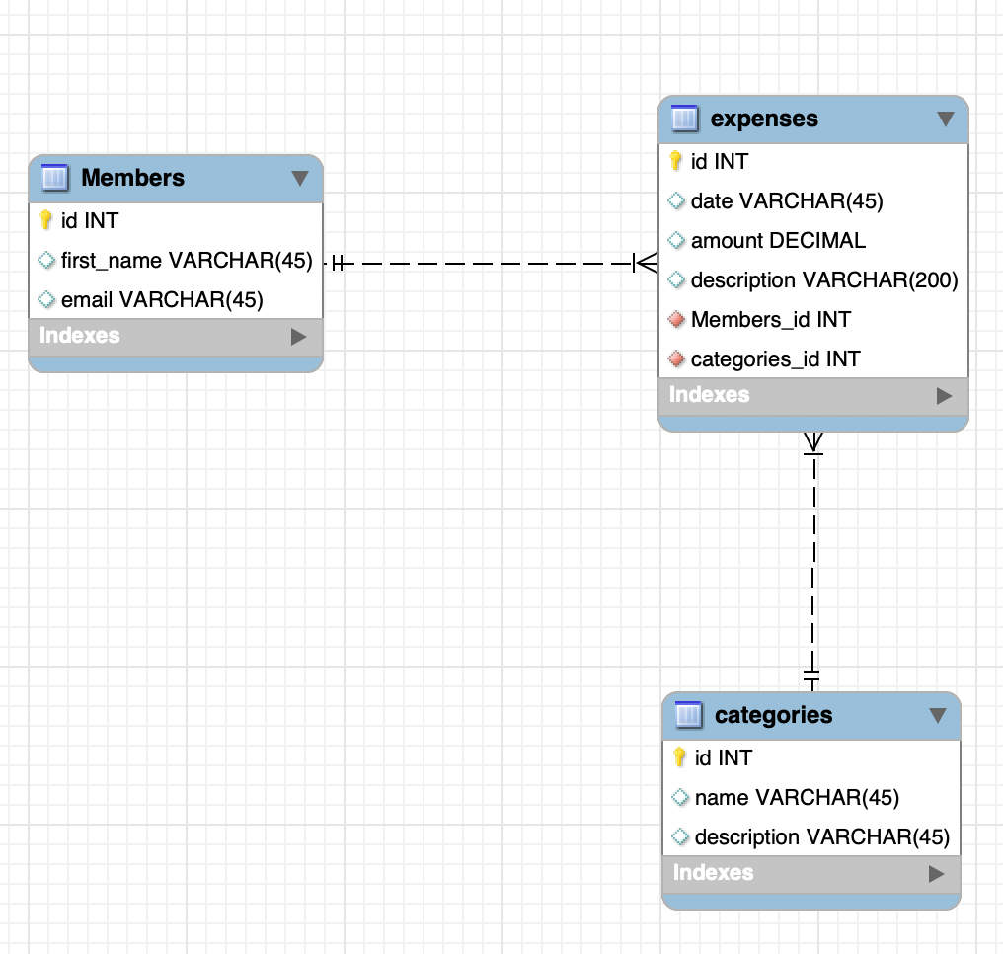
Your system must be built using:
✔ Spring Boot
✔ Spring Data JPA
✔ REST Controllers
✔ Postman API Testing
✔ JSON Request/Response
✔ Proper One-to-Many and Many-to-One relationships [CLO Assessed: CLO-1, CLO-2]

SECTION B — CONCEPTUAL QUESTIONS (10 Marks)

Q1. (5 marks)
Based on the ERD, write the JPA relationship annotations for:
a) Members entity
b) Categories entity
c) Expenses entity
Include: @OneToMany, @ManyToOne, mappedBy, foreign key fields.
CLO Assessed: CLO-1

Q2. (5 marks). Explain:
- Difference between CrudRepository and JpaRepository
- @RestController vs @Controller
- @RequestBody vs @PathVariable
Give examples. [CLO Assessed: CLO-2]

SECTION C — ENTITY IMPLEMENTATION (10 Marks)

Q3. (10 marks)
Write the full Expense entity class, including:
- Annotations (@Entity, @Table, @Data, @NoArgConstructor, @AllArgConstructor)
- Fields with correct types
- @ManyToOne relationships to Member and Category [CLO Assessed: CLO-1]

SECTION D — REPOSITORY & SERVICE LAYER (10 Marks)

Q4. (5 marks). Create repository interfaces:
- MemberRepository
- CategoryRepository
- ExpenseRepository including
List<Expense> findByMemberId(int id); [CLO Assessed: CLO-1]

Q5. (5 marks) Write a ExpenseService class with methods:
getAllExpenses()
addExpense(Expense expense)
getExpensesByCategory(int categoryId)
Just method signatures + one-line description.
CLO Assessed: CLO-1

SECTION E — REST API DEVELOPMENT (10 Marks)

Q6. (5 marks) Design the ExpenseController with endpoints:

API | Purpose
GET /api/expenses | Get all expenses
GET /api/expenses/member/{id} | Get expenses by member
POST /api/expenses | Add expense
PUT /api/expenses/{id} | Update
DELETE /api/expenses/{id} | Delete
Write only method signatures + annotations. [CLO Assessed: CLO-2]

Q7. (5 marks) Write the Request JSON body for creating an expense using the ERD.
[CLO Assessed: CLO-2]

SECTION F — POSTMAN TESTING (10 Marks)
Q8. API Calls + Payloads (10 marks) Write Postman requests for:
Part | API | Method Type | url | payload
a | Create Member | POST | /api/members | {"firstName": "Ali",  "email": "ali@gmail.com"  }
b | Create Category | POST | /api/categories | {"name": "Food",  "description": "Lunch, dinner, snacks"}
c | Create Expense | POST | /api/expenses | {"date": "2025-03-15",  "amount": 1200,  "description": "Team lunch",  "memberId": 1,  "categoryId": 1}
d | Get All Expenses | GET | /api/expenses | Nil
e | Get Expenses by Member | GET | /api/expenses/member/1 | Nil
f | Update Expense | PUT | /api/expenses/3 | {"date": "2025-03-20",  "amount": 1500,  "description": "Updated expense",  "memberId": 1,  "categoryId": 1  }
g | Delete Expense | DELETE | /api/expenses/3
[CLO Assessed: CLO-3]
CLO Mapping Summary Table
Section | Question | Marks | CLO
A | Case Study | — | CLO-1, CLO-2
B | Q1 | 5 | CLO-1
B | Q2 | 5 | CLO-2
C | Q3 | 10 | CLO-1
D | Q4 | 5 | CLO-1
D | Q5 | 5 | CLO-1
E | Q6 | 5 | CLO-2
E | Q7 | 5 | CLO-2
F | Q8 | 10 | CLO-3

